ANALYSTLAB AFRICA
Machine Learning Internship Programme — Week 3
Feature Importance Report
Customer Churn Prediction — What Drives Churn

1. Method
Feature importance was computed using the Random Forest model (the best-performing model overall, ROC-AUC 0.836). Random Forest importance is based on the average reduction in Gini impurity each feature contributes across all trees in the forest — higher values indicate a feature was more useful for splitting customers into churn/no-churn groups.

2. Ranked Feature Importances
Rank | Feature | Importance | Interpretation
1 | Contract | 0.176 | Month-to-month contracts churn far more than annual contracts
2 | tenure | 0.133 | Newer customers are much more likely to churn
3 | MonthlyCharges | 0.093 | Higher monthly bills associate with higher churn
4 | AvgChargePerService | 0.090 | Engineered feature — paying more per service signals dissatisfaction
5 | TotalCharges | 0.078 | Correlated with tenure and billing history
6 | InternetService_Fiber optic | 0.069 | Fiber customers churn more despite premium pricing
7 | TenureGroup | 0.065 | Engineered feature — confirms tenure's non-linear effect
8 | NumServicesSubscribed | 0.041 | Engineered feature — fewer services, less “anchoring”
9 | PaymentMethod_Electronic check | 0.032 | Electronic check payers churn more than other payment methods
10 | InternetService_No | 0.030 | Customers without internet service churn less
11 | OnlineSecurity_Yes | 0.029 | Having security add-ons associates with lower churn
12 | Dependents | 0.025 | Customers with dependents churn slightly less
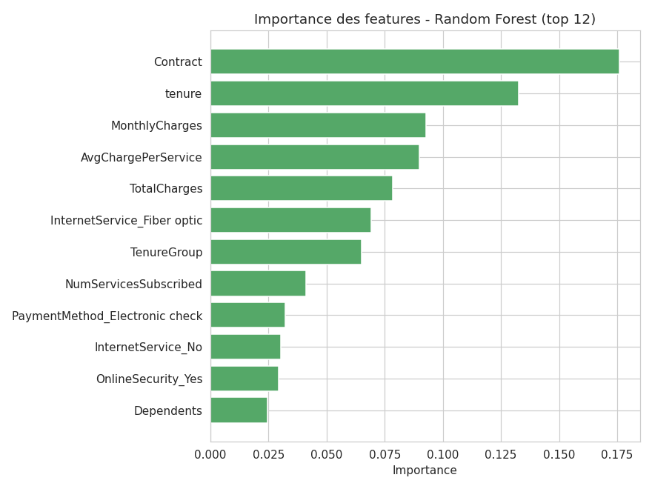
Figure 1. Top 12 features by Random Forest importance.

3. Discussion
The top two features — Contract and tenure — together account for roughly 31% of total importance, confirming that commitment length and customer lifecycle stage are the dominant churn drivers, well ahead of any single service or demographic attribute. This is consistent with the exploratory analysis from Week 1-2, where churn rate dropped from 47.4% for customers in their first year to 9.5% for customers with 4+ years of tenure.
Both features engineered during Week 2 preprocessing — AvgChargePerService (rank 4) and TenureGroup (rank 7) — rank in the top 7, alongside their raw counterparts (MonthlyCharges, TotalCharges, tenure). This cross-validates the feature engineering decisions: the engineered features captured genuine, non-redundant predictive signal rather than simply duplicating information already present in the raw columns.
Billing and service-quality signals form a second tier of importance: MonthlyCharges, TotalCharges, and fiber internet service all rank in the top 6, suggesting price sensitivity and/or service-quality perception play a meaningful secondary role. Notably, fiber-optic customers churn more despite paying a premium — a pattern worth investigating further (e.g. service reliability, competitor pricing for fiber plans).

4. Business Interpretation & Recommendations
- Contract-upgrade incentives: since Contract is the single strongest predictor, offering discounts or perks for upgrading from month-to-month to 1-2 year contracts is likely the highest-leverage retention action available.
- Early-tenure retention program: given how strongly tenure predicts churn, a structured onboarding and check-in program for customers in their first 12 months could directly address the highest-risk segment.
- Investigate fiber service quality: fiber customers churning more despite higher spend suggests a service-quality or expectation gap worth a dedicated customer-experience review.
- Electronic check payers as a secondary target: this payment method's association with higher churn may reflect a less “locked-in” customer relationship (e.g. no auto-pay commitment) and could be targeted with auto-pay enrollment incentives.

